- Write a program to accept two integers and print their sum.
# Write a program to accept two integers and print their sum.
# Author: Aayushi Choudhury
# Class: XI (Science)
# Aster PubliC School

num1=int(input("Enter first integer: "))
num2=int(input("Enter second integer: "))
def sum_of_two_numbers(num1, num2):
return num1 + num2
sum=sum_of_two_numbers(num1, num2)
print("The sum of", num1, "and", num2, "is:", sum)

Outcome:
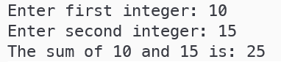

- Write a program that accepts the radius of a circle and prints its area.
# Write a program that accepts the radius of a circle and prints its area.
# Author: Aayushi Choudhury
# Class: XI (Science)
# Aster PubliC School

import math
radius = float(input("Enter the radius of the circle: "))
area = math.pi * radius ** 2
print("The area of the circle with radius", radius, "is:", area)

Outcome:

- Write a program that accepts base and height and calculate the area of a triangle.
# Write a program that accepts base and height and calculate the area of a triangle.
# Author: Aayushi Choudhury
# Class: XI (Science)
# Aster PubliC School

base = float(input("Enter the base of the triangle: "))
height = float(input("Enter the height of the triangle: "))
area = 0.5 * base * height
print("The area of the triangle with base", base, "and height", height, "is:", area)

Outcome:

- Write a program that inputs a student’s marks in three subjects (out of 100) and prints the percentage marks.
# Write a program that inputs a student’s marks in three subjects (out of 100) and prints the percentage marks.
# Author: Aayushi Choudhury
# Class: XI (Science)
# Aster PubliC School
marks1 = float(input("Enter marks for subject 1: "))
marks2 = float(input("Enter marks for subject 2: "))
marks3 = float(input("Enter marks for subject 3: "))

total_marks = marks1 + marks2 + marks3
percentage = (total_marks / 300) * 100

print(f"Percentage marks: {percentage}%")

Outcome:
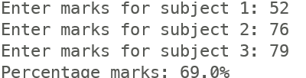

- Write a program to compute the area of square and triangle.
# Write a program to compute the area of square and triangle.
# Author: Aayushi Choudhury
# Class: XI (Science)
# Aster PubliC School

length = float(input("Enter the length of the square: "))
area_square = length * length
print("The area of the square with length", length, "is:", area_square)

base = float(input("Enter the base of the triangle: "))
height = float(input("Enter the height of the triangle: "))
area_triangle = 0.5 * base * height
print("The area of the triangle with base", base, "and height", height, "is:", area_triangle)
Outcome:
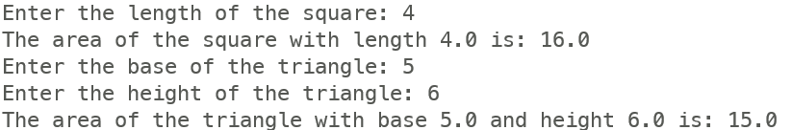

- Write a program to calculate simple interest
# Write a program to calculate simple interest (without function)
# Author: Aayushi Choudhury
# Class: XI (Science)
# Aster PubliC School
p = float(input("Enter the principal amount: "))
r = float(input("Enter the annual interest rate (in %): "))
t = float(input("Enter the time in years: "))
simple_interest = (p * r * t) / 100
print(f"The simple interest is: {simple_interest}")

Outcome:


- Write a program to read two numbers and print quotient and reminder.
# Write a program to read two numbers and print quotient and reminder.
# Author: Aayushi Choudhury
# Class: XI (Science)
# Aster PubliC School

def main():
try:
num1 = float(input("Enter the dividend: "))
num2 = float(input("Enter the divisor: "))

quotient = num1 // num2
remainder = num1 % num2

print(f"Quotient: {quotient}")
print(f"Remainder: {remainder}")
except ZeroDivisionError:
print("Error: Division by zero is not allowed.")
except ValueError:
print("Error: Please enter valid numbers.")

if __name__ == "__main__":
main()
Outcome:
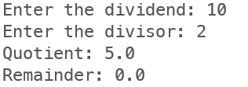

- Write a program to find whether a given number is even or odd
# Program to write a function to find whether the number is even or odd
# Author: Aayushi Choudhury
# Class: XI (Science)
# Aster PubliC School

def find_even_odd(n):
if n % 2 == 0:
return "Even"
else:
return "Odd"

# Test the function
number = int(input("Enter a number: "))
result= find_even_odd(number)
print(f"The number {number} is {result}.")

Outcome:
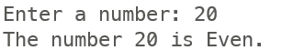

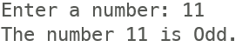

- Write a program to find the largest of three numbers.

# Program to find the largest among three integers
# Author: Aayushi Choudhury
# Class: XI (Science)
# Aster PubliC School
# Get input from the user

num1 = int(input("Enter first integer: "))
num2 = int(input("Enter second integer: "))
num3 = int(input("Enter third integer: "))

# Find the largest number using max() function
largest = max(num1, num2, num3)

# Display the result
print(f"The largest integer among {num1}, {num2}, and {num3} is: {largest}")

Outcome:
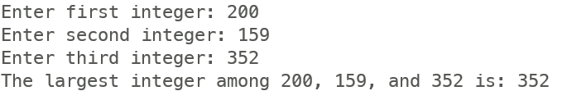

- Write a program to find the lowest among three integers.

# Write a program to find the lowest among the three integers.
# Author: Aayushi Choudhury
# Class: XI (Science)
# Aster PubliC School

# Get input from the user
num1 = int(input("Enter first integer: "))
num2 = int(input("Enter second integer: "))
num3 = int(input("Enter third integer: "))

# Find the lowest number using min() function
lowest = min(num1, num2, num3)

# Display the result
print(f"The lowest integer among {num1}, {num2}, and {num3} is: {lowest}")

Outcome:
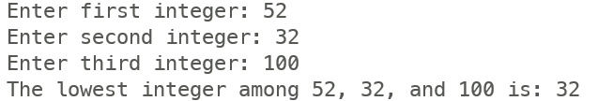

- Write a program that accepts the length and breadth of the rectangle and calculates its area.

- Write a program that accepts weight in Kg and height in meters and calculate the BMI.

- Write a program that reads the number n and print the value of n², n³ and n⁴.

- Write a program to accept the marks of five subjects and calculate the average marks.

- Write a program to accept the height in cm and convert it into feet and inches.
- Write a program that accepts the age and print if one is eligible to vote or not.
- Write a program that accepts two numbers and check if the first number is fully divisible by the second number or not.
- Write a program to read base, width and height of parallelogram and calculate its area and perimeter.
- Write a program to accept the year and check if it is a leap year or not.
- Write a program to obtain x, y, z and calculate 4x⁴+3y³+9z+6π.
- Write a program to input a number and print its square if it is odd, otherwise print its square root.

